Appendix 1- Drawings and Plans
(Please see background papers for the full set of high resolution original drawings and plans, along with a fly through video)

Drawing 1- As proposed, ground floor
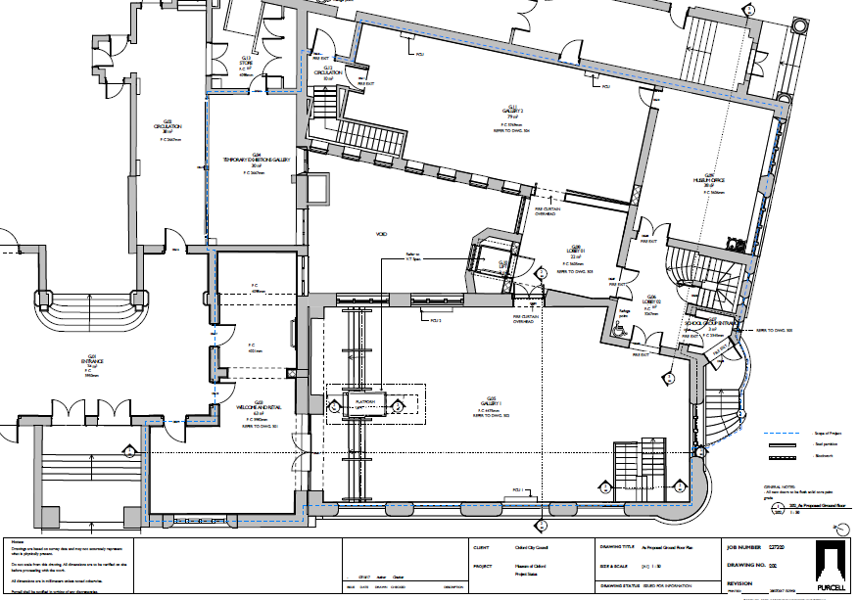
Drawing 2- As proposed, basement
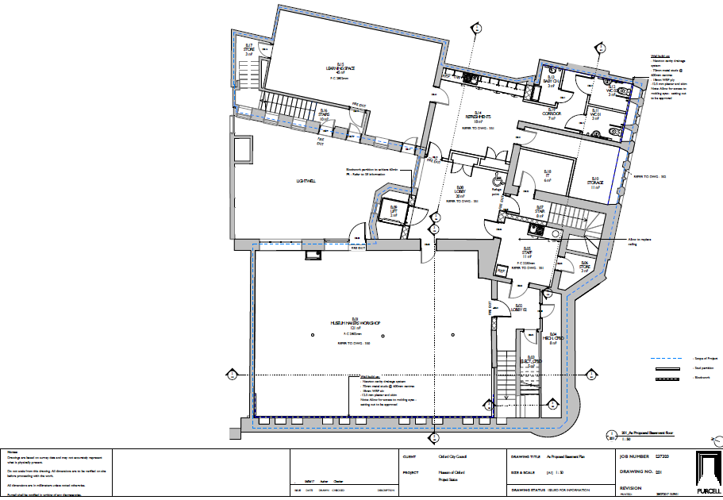

Drawing 3- Exhibition fit out design, ground floor
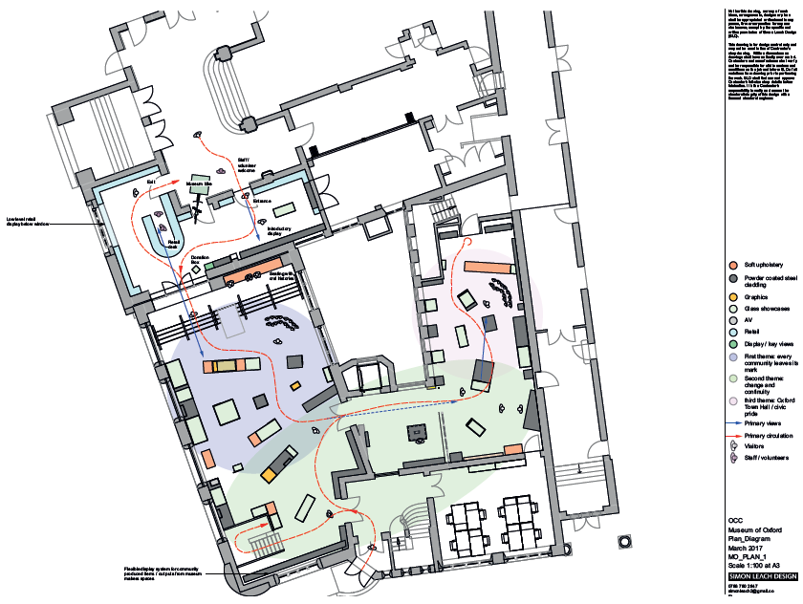

Drawing 4- Exhibition fit out design, basement
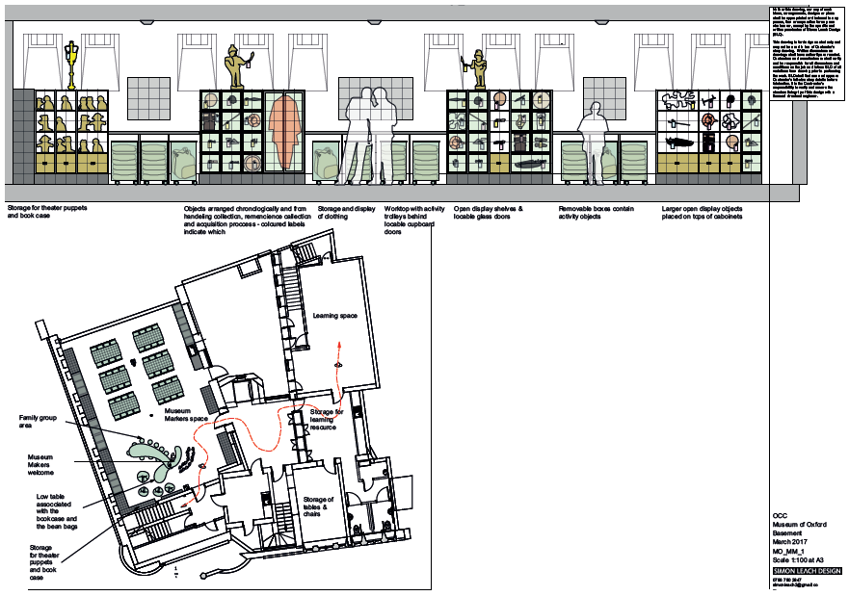

Artist impression- Gallery 1, ground floor

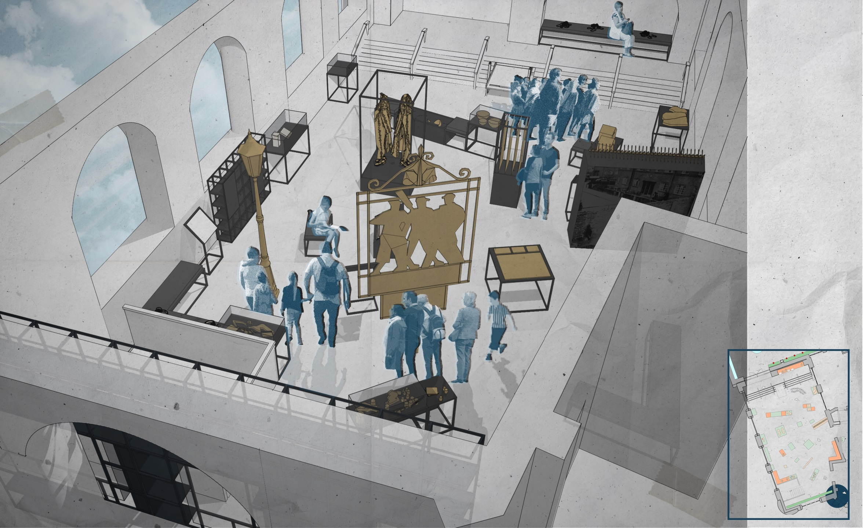

Artist impression- Gallery 2 and lobby, ground floor

